

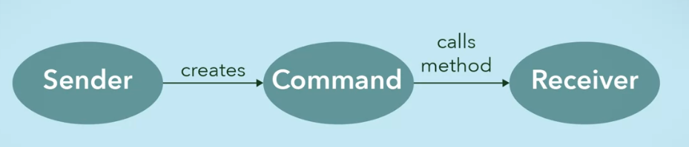

* Invoker/ Command manager
  + Like the secretary
  + Keeps track of the commands, making sure they are executed properly

Where to implement this?

* Store and schedule requests
  + 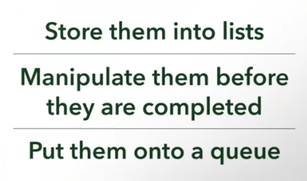
* Methods that can be undone or redone
  + 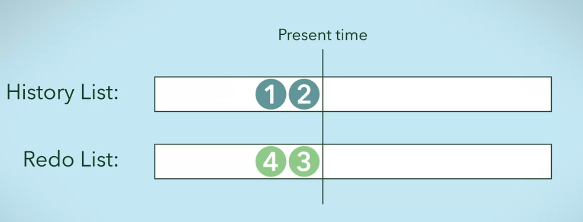
* Decouples
  + Let the command object deal with the request

UML Diagram of Command Pattern

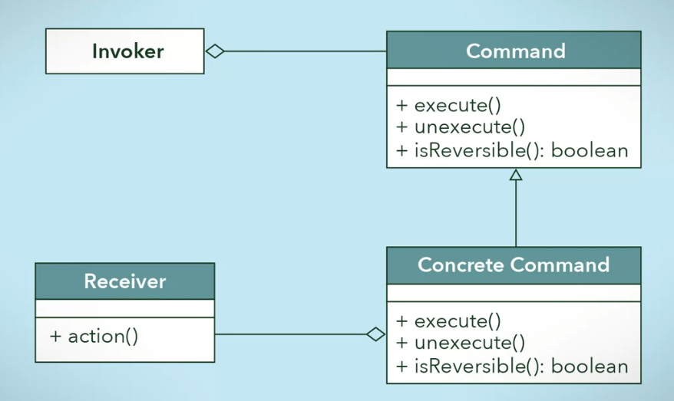

Example of a concrete command

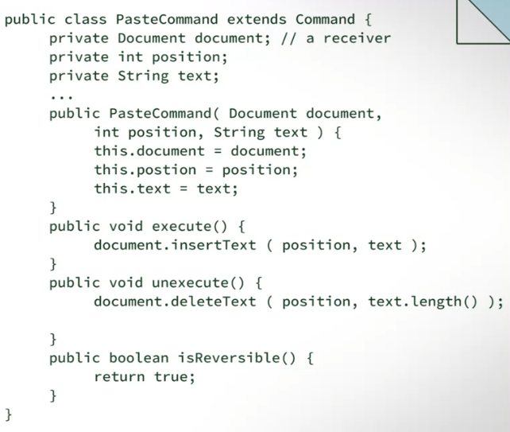

Example of an Invoker

